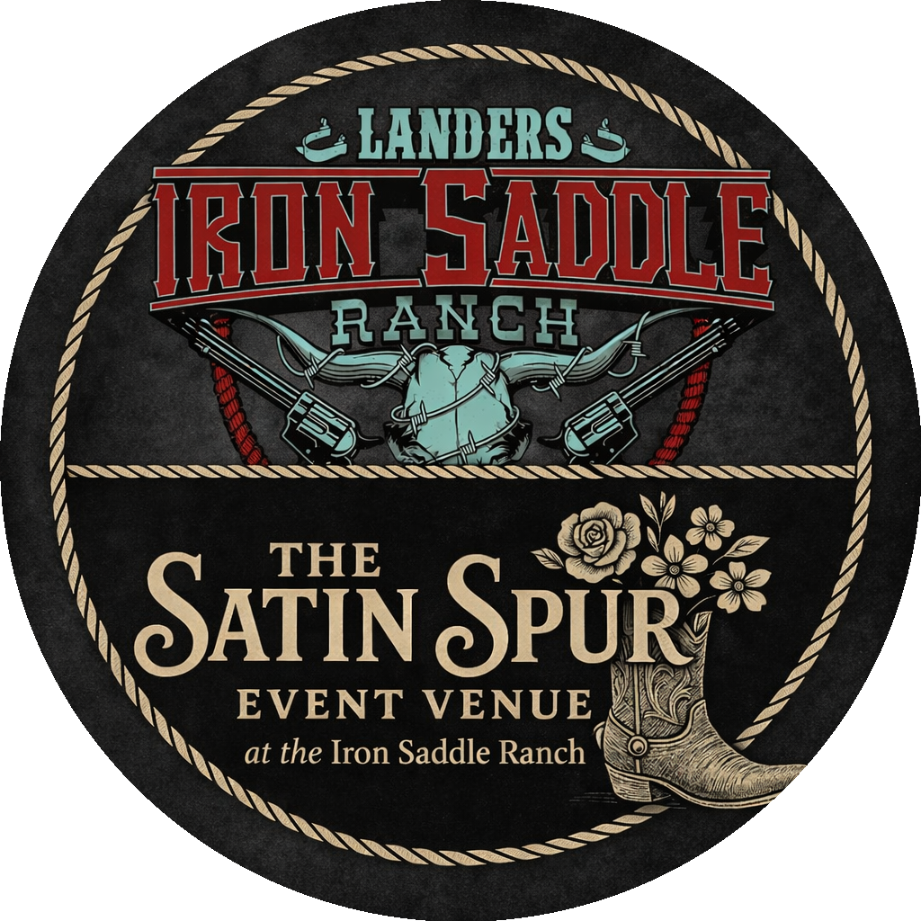
2026 Sponsorship Opportunities
The Satin Spur is excited to announce a full schedule of events for the 2026 season, including rodeos, bulls & broncs, roping, sorting, barrel racing, live bands, and festivals. Our Whippoorwill Rodeo alone brings in a consistent crowd of 3,000–4,000+ attendees every year.
Please select your desired sponsorship level(s) below and return this form with payment. We appreciate your support and the opportunity the showcase your business this year!
Business Name: ________________________________
Email Address: ________________________________
Phone Number: ________________________________
Contact Name: ________________________________
Sponsorship Options (Check All That Apply)
☐ Iron Saddle Sponsorship – $2,500
4x8 arena banner • Facebook spotlight posts • Verbal recognition • Logo on rodeo shirts • 4 rodeo shirts • 4 rodeo tickets
☐ Gold Buckle Sponsorship – $1,000
2x8 arena banner • Facebook spotlight posts • Verbal recognition • Logo on rodeo shirts • 2 rodeo shirts • 2 rodeo tickets
☐ Silver Trophy Sponsorship – $500
2x8 arena banner • Facebook mentions during rodeo weeks • Verbal recognition • Logo on rodeo shirts
☐ Rodeo Rookie Sponsorship – $250
2x4 arena banner • Facebook mentions during rodeo weeks
Payment Method: ☐ Check Enclosed ☐ Other: ________________________________
Please email logo and banner design to satinspur@ironsaddleranch.com
Return with payment to: The Satin Spur, 3734 Cross Rd., Salem, IL 62881

